CRUD Operations
Q.01 Create a new database called student management.
Query use student_ management
Output switched to db student _management
Q.02 Create a collection called students in the student_ management database.
Querydb. create Collection("Students”)
Output {ok: 1}
Q.03 Insert at least five student records into the students collection. Each record should have the following fields:
student_ id (integer)
name (string)
age (integer)
department (string)
courses (array of strings)
grade (string)
Query
([{student_id:101, name:“ Amit", age:23, department :"computer science" ,courses:[" DBMS ","operating systems"], grade: "A"},
{student_id:102, name:" Aryan ", age :22, department :"information technology ",courses:["web development"," networking "],grade: "B+"},
{student_id:103,name:"Rahul",age:20,department:"mechanical engineering ",courses :[" thermodynamics ","fluid mechanics"],grade: "C"},
{student_id:104,name:"Neha",age:19,department:"electronics",courses:["digital circuits"," signals "],grade: "D"},
{student_id:105,name:"Arjun",age:24,department:"civil engineering ",courses:["structural analysis ","surveying"],grade :"E"}])
Output
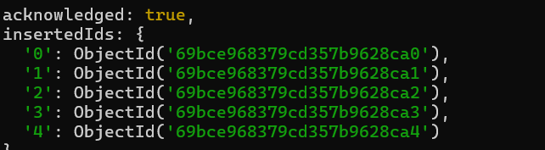
Query db. Student .find()
Output
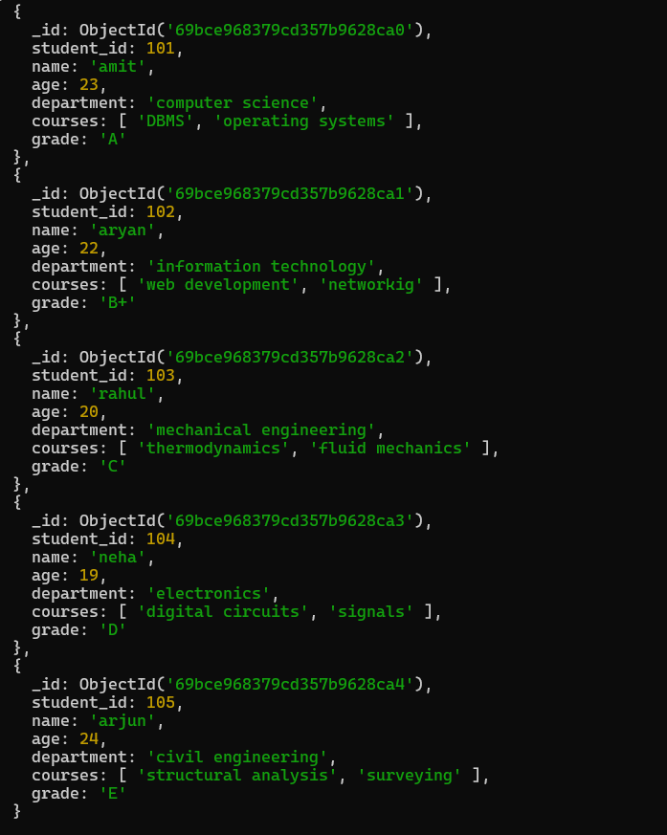
Query the Collection
Q.01 Retrieve all students who are in the "Computer Science" department.
Query db. Students. find({department :"computer science"})
Output
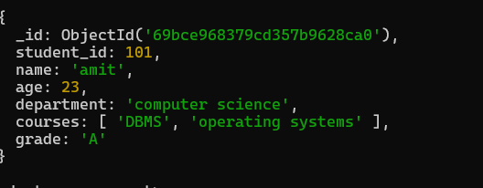
Q.02 Retrieve students who have an age greater than 21.
Query db. Students .find({age:{$gt:21}})
Output
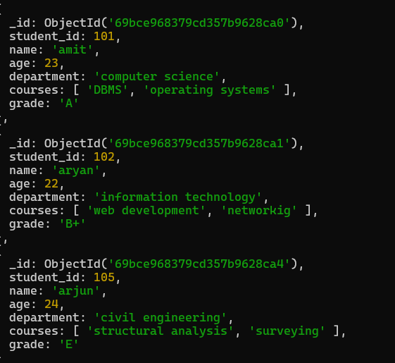
Q.03 Retrieve students who are taking the "Database Systems" course.
Query db .Students .find({ courses :"database system"})
Output
Q.04 Retrieve students with a grade of "A".
Query db. Students .find({grade :"A"})
Output
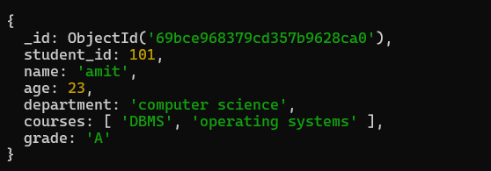
Update Documents
Q.01 Update the age of a student with student_ id 101 to 21.
Query db. Students. updateOne ({student_id:101},{$set:{age:21}})
Output
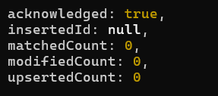
Query db. Students .find()
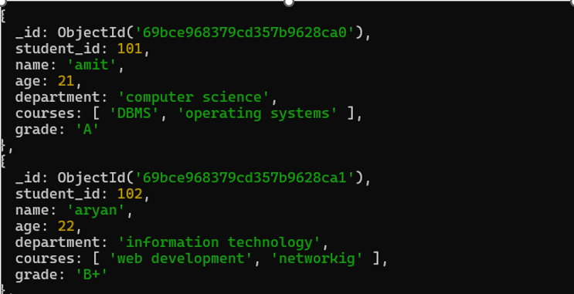
Q.02 Add a new course, "Machine Learning", to the courses array for students in the "Computer Science" department.
Querydb. Students .update Many ({department: "computer science"},{$add To Set:{courses :"machine learning"}})
Output
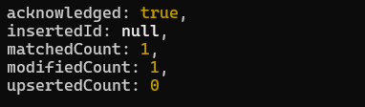
Query db. Students .find()
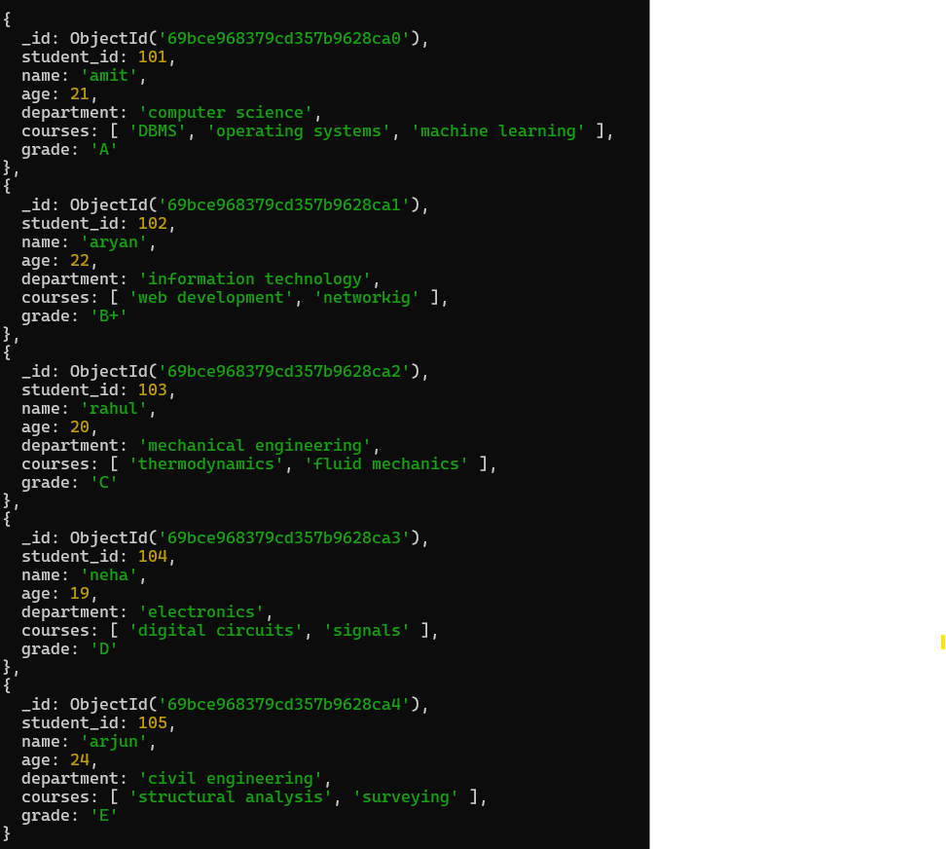
Delete Documents
Q.01 Delete a student record with student _id 105.
Query db. Students. delete One ({student_id:105})
Output
Query db. Students .find()
Output

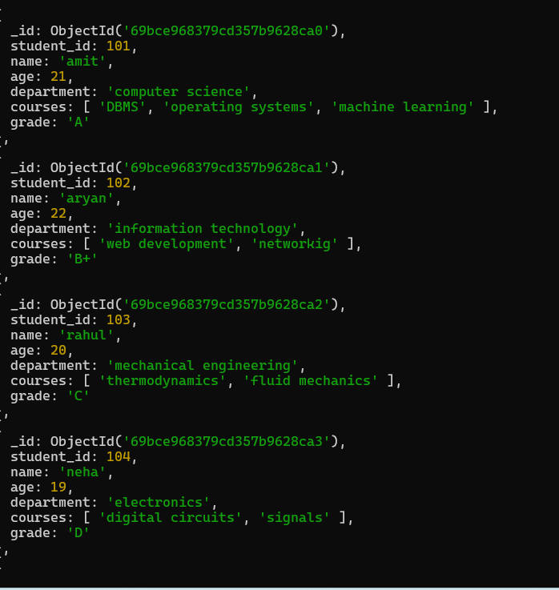
Q.02 Delete all students who have a grade lower than "C".
Querydb. Students. Delete Many({grade:{$gt:"C"}})
Output
Query db. Students .find()
Output
